Sarkar, Mohul (Student)

Cisco ASA 5505 Firewall Lab

Mohul Sarkar

**Purpose:**

The purpose of learning how to use a Cisco ASA 5505 Firewall is to protect networks from external threats and to provide secure access to internal resources. It is commonly used to provide firewall, VPN, and intrusion prevention services. It can also be used to monitor and control network traffic between different internal networks and the public internet. This firewall provides stateful packet inspection (SPI) and application layer firewall protection, as well as intrusion prevention system (IPS) and antivirus protection. It also includes VPN capabilities, allowing secure remote access to the network. Additionally, the Cisco ASA 5505 Firewall is the only device in the ASA series with an integrated 4-port switch, so it can be used to segment the network for added security. This lab includes the use of Cisco ASDM-IDM Launcher which will require the download of various software along with initial configurations to be able to access the firewall using a privileged account.

**Background Information on Lab Concepts:**

Based on the previous labs we have done I have gotten very familiar with using web interfaces to access firewall. This lab introduces a new concept of using java and Cisco ASDM which I have not used in a previous lab before. Although Cisco ASDM is another web interface, another layer of complexity is applied that you must use java for configuration. This is the first lab so far where there has been Java code used to setup the router rather than Cisco IOS code. This lab requires I will need to gain knowledge on the functionality of the Cisco ASDM-IDM Launcher and how to use the Java Control Panel to be able to apply specific firewall network settings. This firewall is easy to manage and set up, making it an ideal choice for small and mid-sized businesses. The Cisco ASA 5505 is a cost-effective solution for businesses looking for comprehensive security protection.

**Lab Summary:**

In this lab you use multiple program files including Java, Cisco ASDM and PuTTy to navigate through the configuration of the Cisco ASA 5505 firewall. This lab consists of inputting an algorithm into the launcher to be able to contact devices using the Cisco ASDM Launcher and use the GUI tools to manage the Cisco ASA security appliances. Using a Java algorithm to provide secure authentication and authorization of users attempting to access the ASDM, a combination of strong encryption algorithms to provide the highest level of security possible. It also provides access control capabilities to ensure that only authorized users can access the ASDM-IDM. The latest version of Java must be downloaded along with the latest version of Cisco ASDM to allow for proper compatibility and functionality.

**Lab Commands:**

1. Enter the command line by connecting the ethernet cable and console cable to a device until the CLI appears

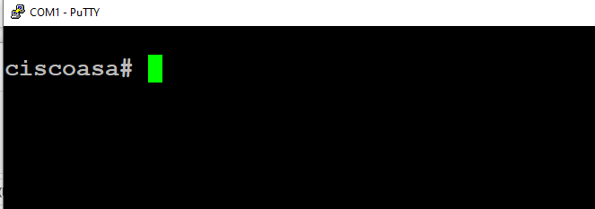

1. Enter global config mode with “configure terminal” command and enter “config factory-default” and reload the router







1. Set a password for the router for security



1. Go to https://192.168.1.1, select advanced options and enter anyway
2. Once prompted with Cisco ASDM, select Install ASDM Launcher or alternatively you can navigate to official cisco website and download ASDM from the downloads page

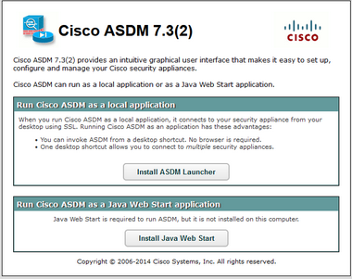

1. Navigate to https://www.java.com/download, and begin the download process of the latest version of java

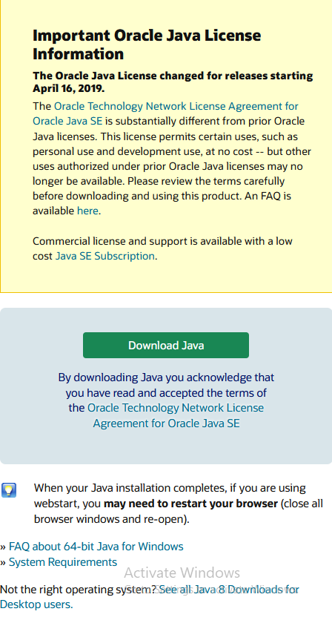

1. Once Java is installed on device, create unique username and password for account to be able to access firewall through



1. Navigate to “Windows” tab, and right-click on Cisco ASDM-IDM Launcher to bring up Launcher Properties window. Then navigate to Shortcut tab and verify the target is specified and it runs in a normal window

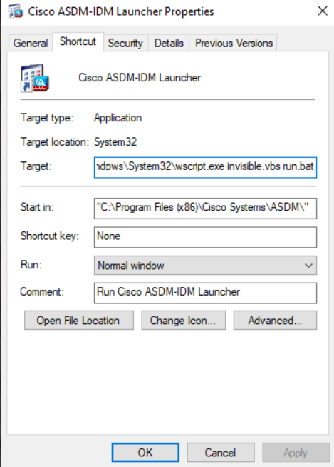

1. Enter Java application by right-clicking on Start button and selecting Control Panel. Once in the Windows Control Panel, select Programs and navigate to the Java icon, where you can open the Java Control Panel

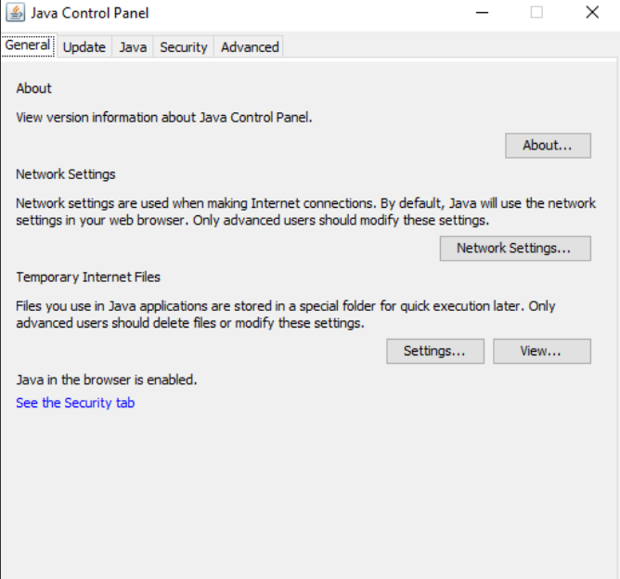

1. Within the same window, navigate to Advanced and select the various Advanced Security settings on the multi-select dropdown interface

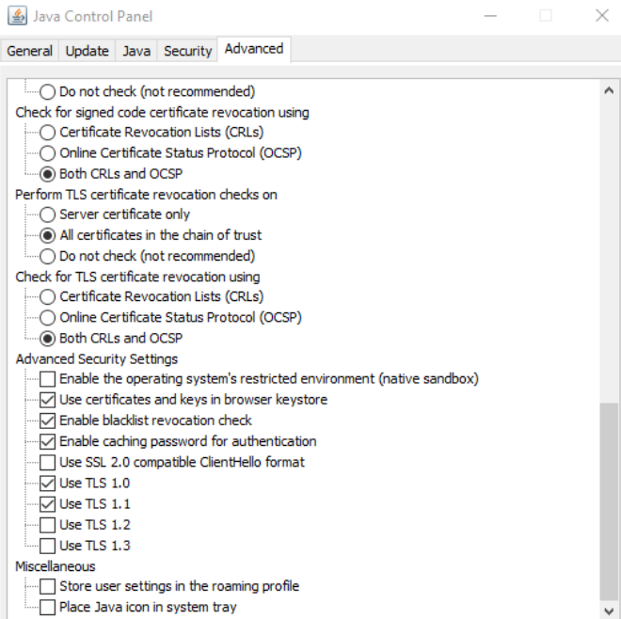

1. Enter Notepad++ and create a new algorithm named “java security”. Verify functionality on the whole code and in specific visit line 779-784 to set up access to web GUI

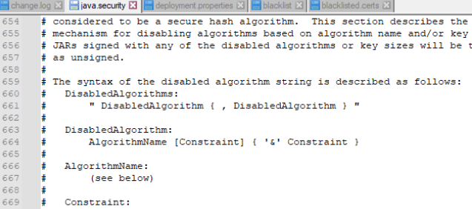

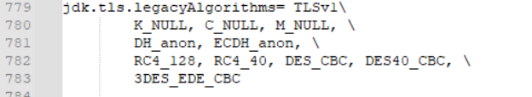

1. After applying Java settings, enter Cisco ASDM-IDM Launcher using credentials created on PuTTy in configuration mode and select default IP address “192.168.1.1”

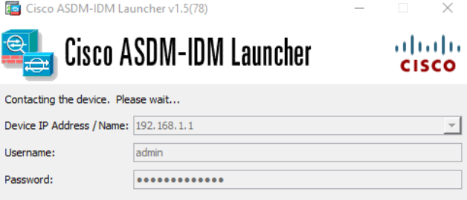

1. If after entering credentials and IP address, you are unable to access firewall through launcher, troubleshoot possible java bugs and reload launcher until ASA functions

**Problems:**

One problem I had when entering Cisco ASDM using Java Web Start is that the application failed to launch due to outdated Java components, incorrect settings in the Java control panel, or a lack of permissions. After navigating to the website and downloading the latest version of Java, the Cisco ASDM was able to boot successfully but I got another bug when the incorrect settings in the control panel were set. After debugging the Network settings within the Java Control Panel and setting the account used to enter the interface with sufficient permissions, I was able to navigate to the configuration of the ASA firewall through the ASDM Launcher, but the device did not fully load past 17 percent.

**Conclusion:**

This lab showed how to enter a Cisco ASA 5505 using Java Runtime Environment and how to download and use the Cisco ASDM-IDM Launcher. This is the first lab that utilizes Java code alongside Cisco IOS code making the configuration slightly more complex. The main problem I ran into was compatibility issues with my Java version, but after updating to the latest version, I was able to begin entering the Launcher. This lab was unique compared to the recent labs we have done, as most of those labs simply use a default IP address on a web browser interface, while this had a Launcher application. Although the lab was incomplete, the steps so far gave me a lot of insight into configuring Cisco routers with Java and helps to troubleshoot future Java control panel issues I might face. Learning how to configure ASA can aid in future labs that contain Java within the configurations and additionally helps with familiarizing myself with ASA policies and the unique functions of this router.